Cloud Computing Lab

Safa Jahangir
BSE-V B
2023-BSE-056

LAB 07

Task 1 — Print & filter environment variables
- task1_printenv_all.png
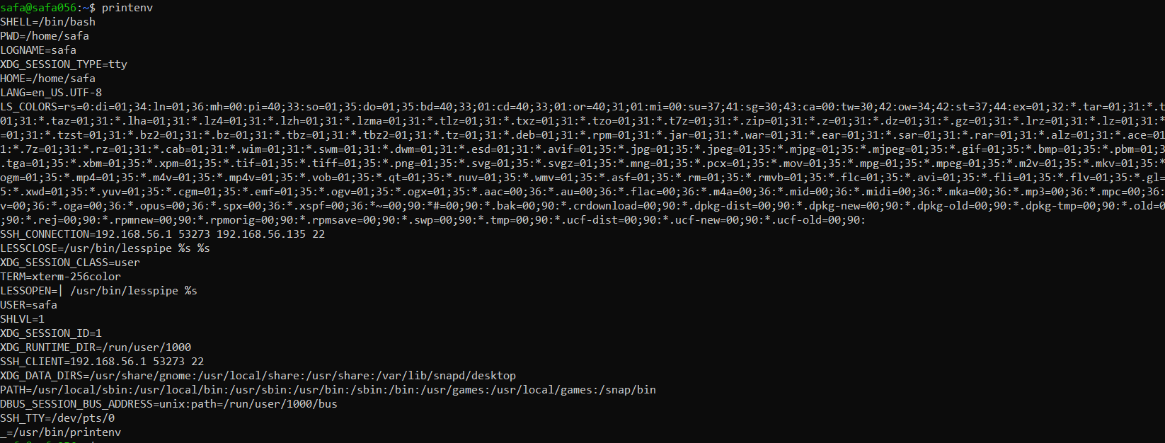
- task1_grep_shell_home_user.png
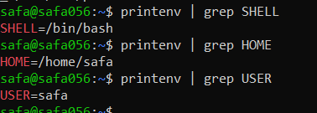

Task 2 — Export DB_* variables temporarily and observe scope
- task2_exports_all.png
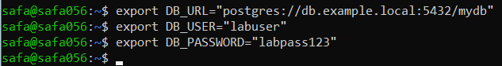
- task2_echoes_all.png
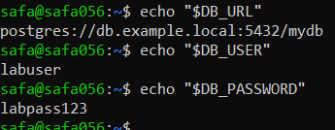
- task2_printenv_grep_db.png
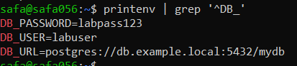
- task2_after_restart_checks.png
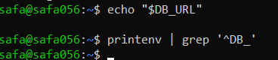

Task 3 — Make DB_* variables persistent in ~/.bashrc
- task3_bashrc_added.png
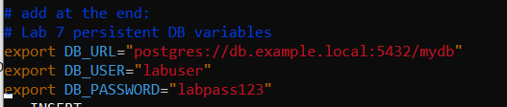
- task3_source_and_verification.png
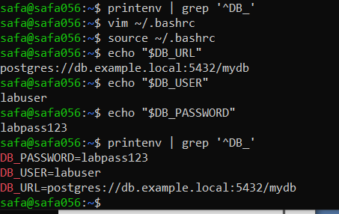
- task3_after_restart_persistent.png
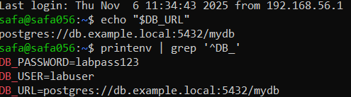

Task 4 — System-wide environment variable, welcome script, and PATH
- task4_etc_environment_before.png
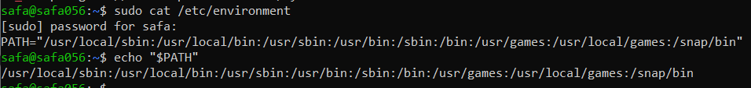
- task4_echo_path_before.png
- task4_etc_environment_edit_vim.png
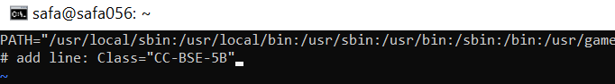
- task4_etc_environment_after.png
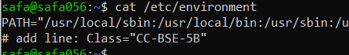
- task4_echo_class_and_path.png
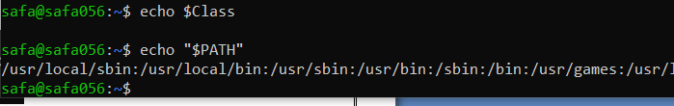
- task4_welcome_create_and_chmod.png
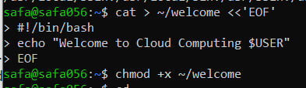
- task4_welcome_run_dot.png
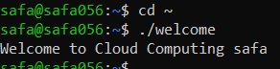
- task4_bashrc_path_line.png
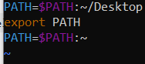
- task4_bashrc_source_and_welcome.png
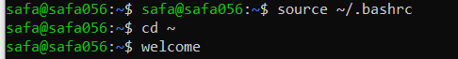

Task 5 — Block and allow SSH using ufw
- task5_ufw_enable_and_status.png
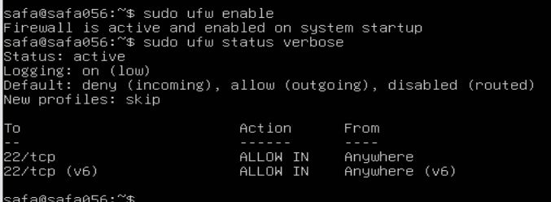
- task5_ufw_deny_22_and_status.png
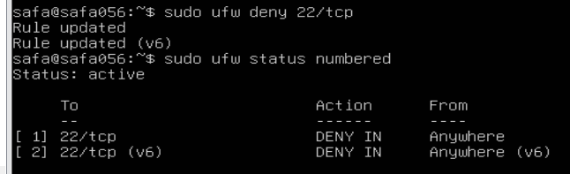
- task5_ssh_attempt_blocked.png
- task5_ufw_allow_reload_status.png
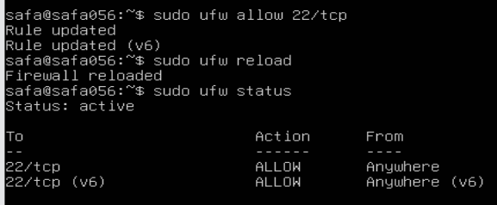
- task5_ssh_success_after_allow.png
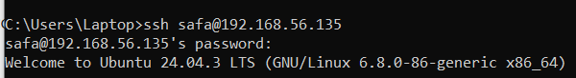

Task 6 — Configure SSH key-based login from Windows host
- task6_windows_sshkey_and_list.png
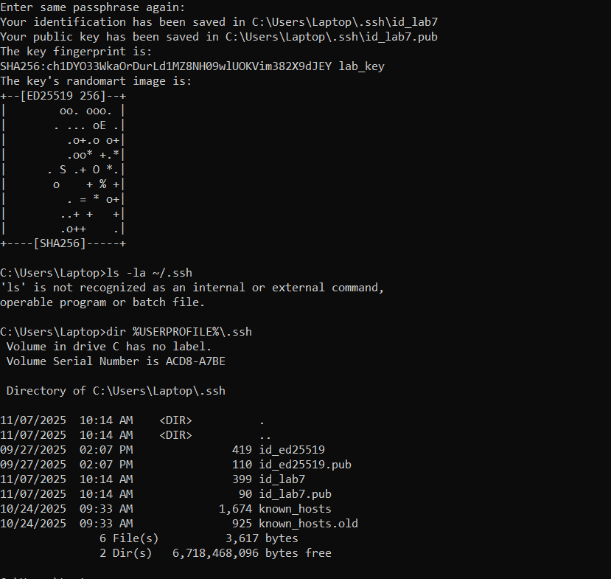
- task6_windows_public_key.png
- task6_ windows_known_hosts_cleared_and_empty.png
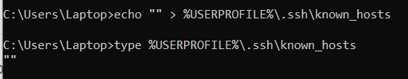
- task6_ windows_ssh_accept_hostkey_and_login.png
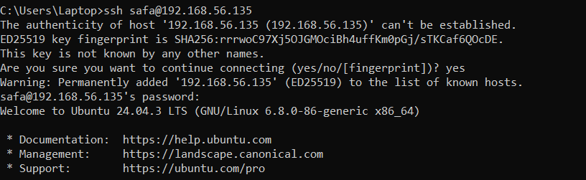
- task6_windows_known_hosts_after_connect.png
- task6_server_clear_authorized_keys.png
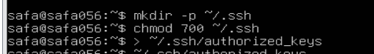
- task6_ssh_with_identity_file.png
- task6_ssh_passwordless_login.png
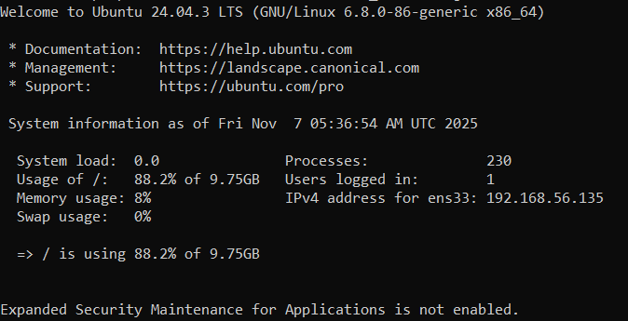
- task6_ssh_with_identity_file.png
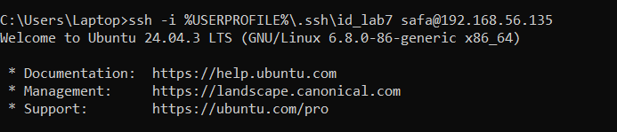

Exam Evaluation Questions

Q1: Quick Environment Audit
EE_q1_env_all.png
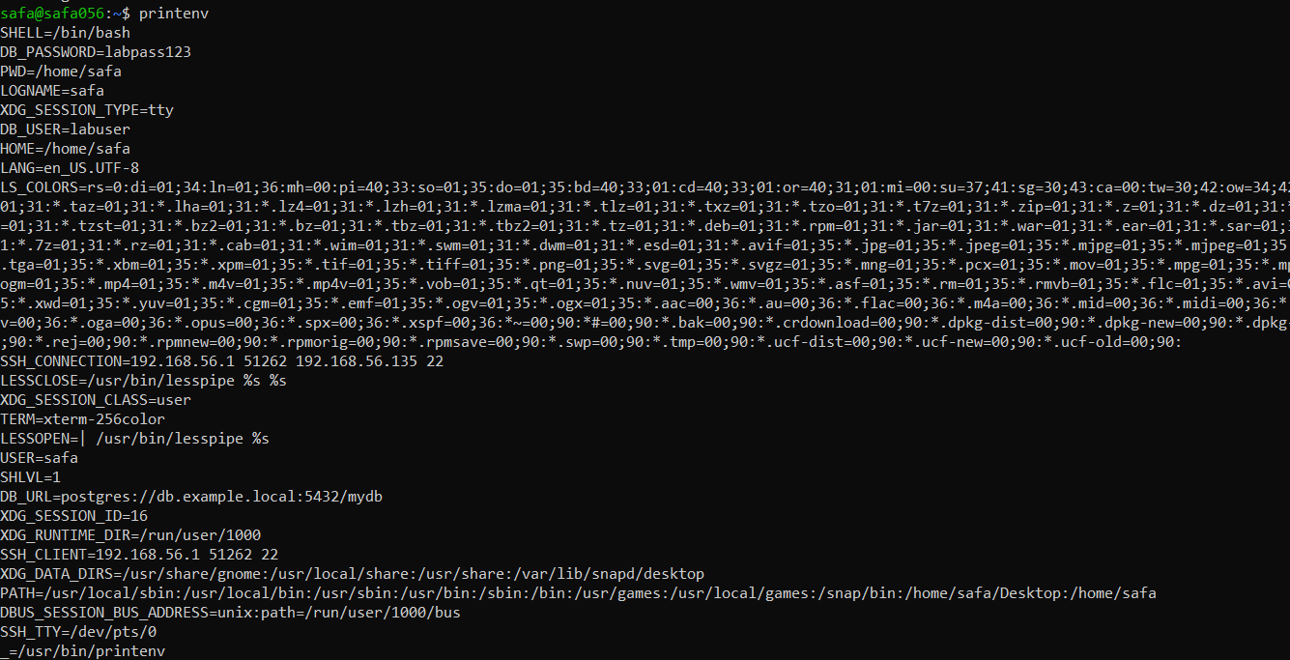
EE_q1_env_filters.png
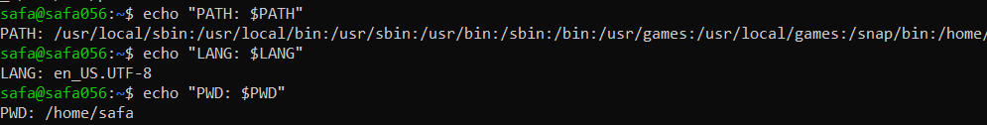

Q2: Short-lived Student Info
EE_q2_exports.png
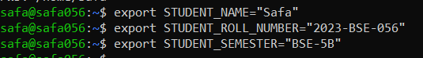
EE_q2_echoes.png
EE_q2_printenv_grep.png
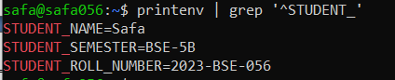

EE_q2_after_restart.png
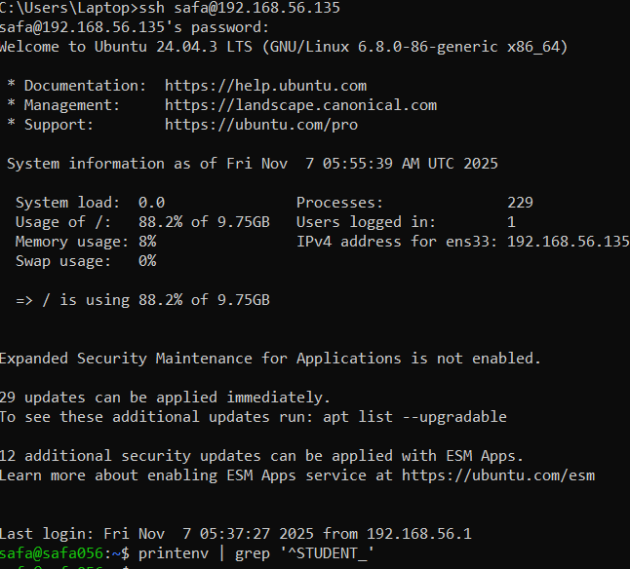

Q3: Make It Sticky (Persistence Check for Student Info)
EE_q3_bashrc_editor.png
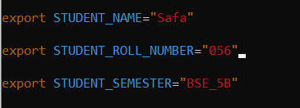
EE_q3_after_source.png
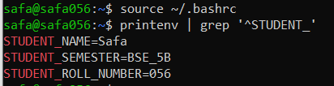
EE_q3_after_restart.png
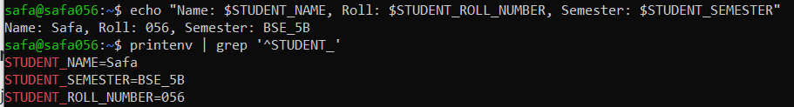

Q4: Firewall Rules: Block and Restore Ping (ICMP)
EE_q5_ufw_enable_status.png
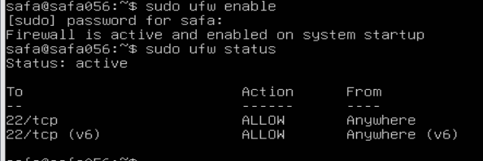
EE_q5_ufw_deny_ping_status.png
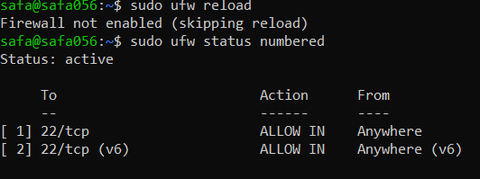
EE_q5_ping_blocked.png
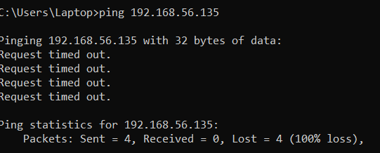
EE_q5_ufw_allow_ping_status.png
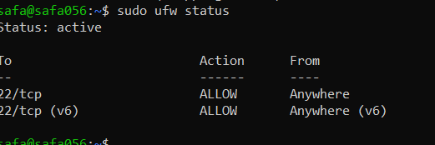
EE_q5_ping_success.png
